2018 Steering Column

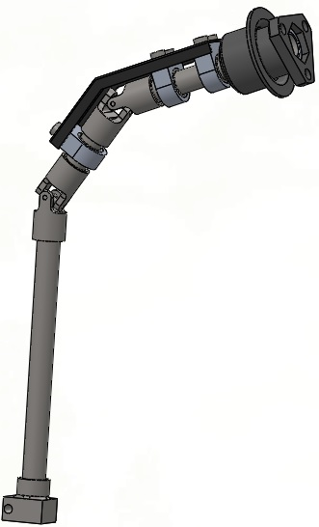

**Specifications:**

Total Weight = 1.59 lbs = 720.0 grams

Material: 1018 Steel, Aluminum

Joint Angles: 34 degrees (In Phase)

Wall Thickness = 0.035” (Minimum)